Getting started DDDUrban

Thomas Skaugen, HM/NVE

1. **Downloads**

DDD (Distance Distribution Dynamics) model is a rainfall- runoff model (Skaugen et al, 2020) coded in Julia (download from <https://julialang.org/>) and is edited in Jypyter notebooks (hereafter called «notebook»).

After dowloading Julia and Jypyter, open Julia and write in the Julia window: “import Pkg; Pkg.add("IJulia") “

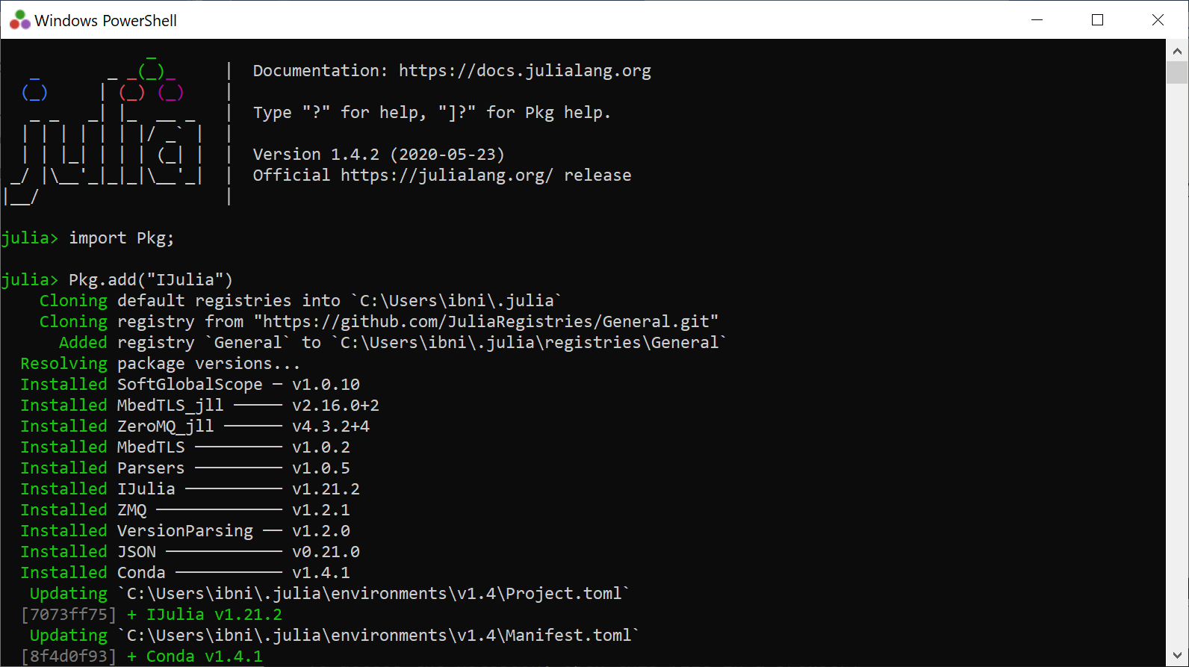

This ensures that Julia and Jypyter (in mysterious ways) are connected.

After, download the following packages(while still in the Julia window) needed by DDD. Write:

Pkg.add("CSV")  
Pkg.add("Distributions")  
Pkg.add("LsqFit")  
Pkg.add("Statistics")  
Pkg.add("Dates")  
Pkg.add("DataFrames")

Pkg.add("BlackBoxOptim")  
Pkg.add("Plots")

The package «IJulia» must be installed before you can open a notebook.

**2) Install DDDUrban**

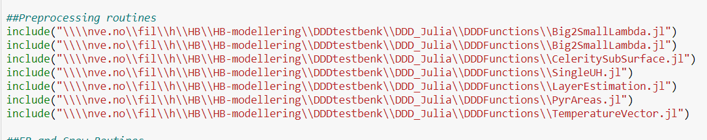

You need too organise subroutines, the main routine and the «run» script appropriately. The above image show how I have organised (which directory) the subroutines.

The main routine is located at the same directory:



«kjør» scriptet ligger på One-driven min (erfaringsmessig er den lett tilgjengelig i Jyputer)

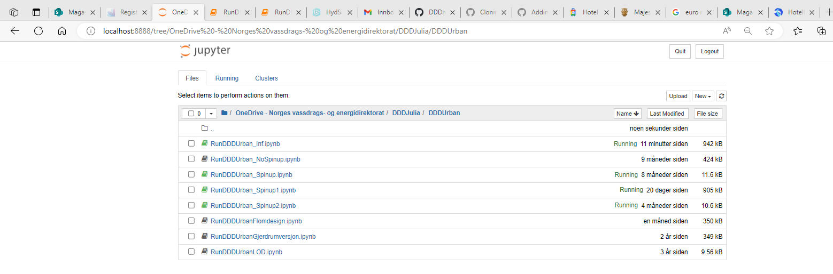

Now open RunDDD.ipynb in notebook og edit all the paths so that they can be found by the program dem. The top of RunDDD may look like this:

Remember to save (ctrl s)

**3) Running a catchment**

Run, for example, the catchment 56.1 (Sandsli in Bergen, Norway) to check that everything works. Remember to edit paths so the the runscript finds the parameterfile (paramfile), input datafile (ptqfile) and where to place the resultfiles (r2fil og utfile).

Make sure that «kal=0» when running for the first time. It means that the calibration mode is turned off and you run the catchment with the parameters stated in the parameterfile. If «kal =1» you run a calibration.

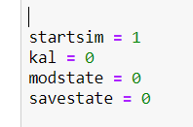

You start the script, i.e. run the model by “ctrl Enter”

***NB Julia must be started in order to run the model***

After a quite few seconds (many timesteps) the model is through and the following appear on the screen at the bottom:

**4) The parameter file**

The parameter file is a *.csv file (which is also the type of the inputfile)

The following figure show the same parameters with comments

**5) Input fil**

Input to DDD is precipitation and temperature in additions to runoff (necessary only if you want to see the skill score or calibrate, see below) in the temporal resolution of your choice.

The top line is only for illustration purposes, is not to be included in the ptq (p-precip, t-temperature, q- runoff) file. The last column is observed runoff. If runoff is not available, have 0 or some other number, the column needs to have a number. The first 5 columns are the time stamp, the next 10 columns are precipitation for 10 elevation zones, the next 10 columns are, temperature for 10 elevation zones. For small urban catchments the spatial variability can be assumed to be modest so that the values in the different elevation zone may be set equal



**6) Output**

When «kal=0» a result file is produced. This is a quite substantial file, which is this example has 34 columns. (the number of columns may differ in the different versions. You have to check the statement writing to the “simresult” data frame in the main routine (DDD*…). In this example the columns are:

1: "yr", year

2: "mnt", month

3: "day", day

4: "hr", hour

5: "min", minute

6: "p", precip [mm]

7: "t", temperature [°C]

8: "qobs", observed runoff [m³/s]

9: "qtot", simulated total runoff [m³/s]

10: "qP", simulated runoff P-area [m³/s]

11: "qIP", simulated runoff IP-area [m³/s]

12: "qBog", simulated runoff wetlands [m³/s]

13: "SCA", Snow covered area P-area[fraction]

14: "SWE", Snow water eqauivalent P-area [mm]

15: "L_P", Storage subsurface, P-area [mm], inkl overland flow

16: "L_IP", Storage subsurface, IP-area [mm], inkl overland flow

17: "Def_P", Subsurface deficit P- area [mm]

18: "Def_IP", Subsurface deficit IP-area [mm]

19: "sm_P", soilwater P-area [mm]

20: "sm_IP", soilwater IP-area [mm]

21: "ea_P", aktuell evapotranspiration P-area [mm]

22: "ea_IP", aktuell evapotranspiration IP-area [mm]

23: "qtot_mm", total runoff in [mm]

24: "sm_Bog", soilwater wetlands [mm]

25: "ea_Bog", evapotranspiration wetlands [mm]

26: "rivstate", water in the rivernetwork [mm]

27: "L_bog", Storage subsurface wetlands [mm]

28: "SCA2", Snow covered area IP-area[fraction]

29: "SWE2", Snow water equivalent IP-area [mm]

30: "wcs1", liquid water in snowpack P-area [mm]

31: "wcs2", liquid water in snowpack IP-area [mm]

32: "ss1", storage subsurface ex. overland flow P-area [mm]

33: "ss2", storage subsurface ex. overland flow IP-area [mm]

34: "qOF" runoff overland flow [m³/s]

To read and plot from the result file, use an R-script.

**6) Calibration**

To calibrate, set «kal=1» in the run script and you choose how many calibration-rounds you want the model to run. If you only calibrate two parameters, the convergence happens quite fast (300 rounds, MaxSteps=300). More parameters demand more rounds.



The number of parameters to calibrate is decided by expand or minimize the range of the parameters.



Only some parameters has a range in the above example

**References**

Skaugen, T. D. Lawrence and R. Z. Ortega, 2020. A parameter parsimonious approach for catchment scale urban hydrology – Which processes are important?. Journal of Hydrology X, 8, <https://doi.org/10.1016/j.hydroa.2020.100060>

Skaugen, T. and Weltzien, I. H., 2016. A model for the spatial distribution of snow water equivalent parameterised from the spatial variability of precipitation, *The Cryosphere*. 10, 1947-1963, doi:10.5194/tc-10_1947_2016.

Tsegaw, A.T., Skaugen, T, Alfredsen, K & Muthanna, T.M: [A dynamic river network method for the prediction of floods using a parsimonious rainfall-runoff model](https://iwaponline.com/hr/article/doi/10.2166/nh.2019.003/69546/A-dynamic-river-network-method-for-the-prediction). Hydrology Research 2019; doi.org/10.2166/nh.2019.003, ISSN 1998-9563 (Published online August 26 2019).